Step1: Open Windows PowerShell ISE and use the **Connect-AzAccount** cmdlet

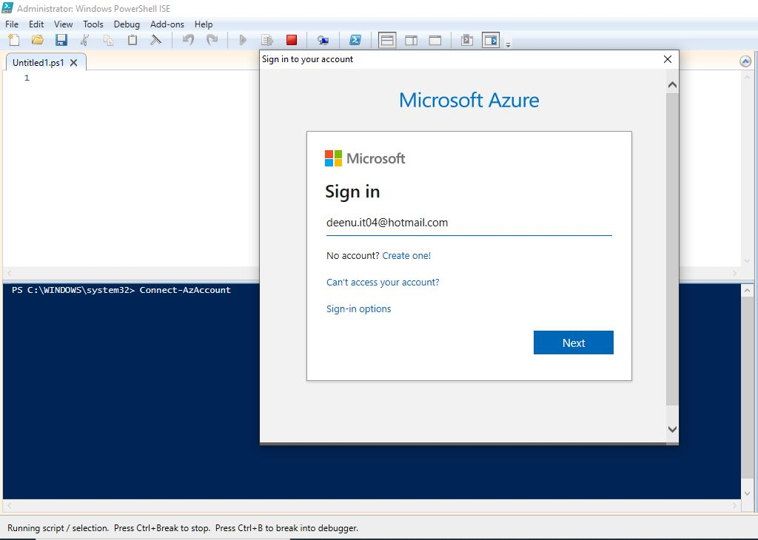

Step2: Enter credentials and sign in

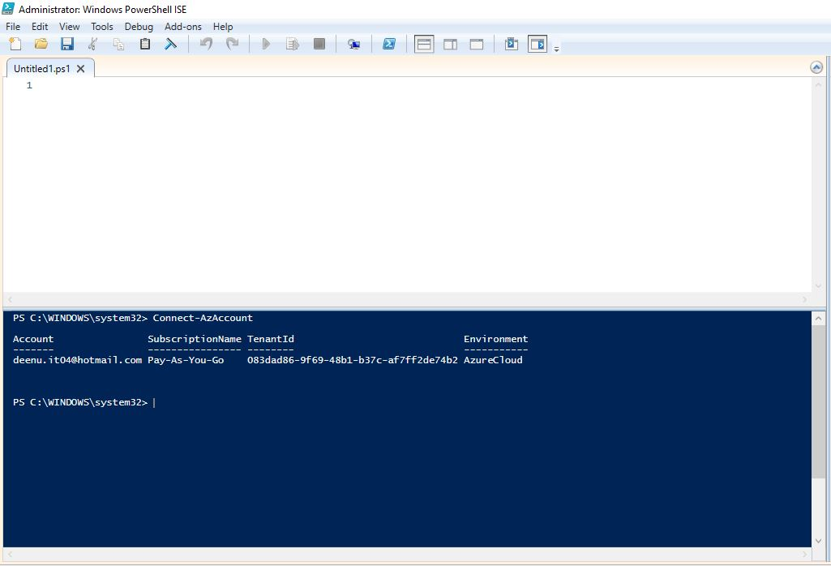

Step3 : Create Virtual Network with name **fc3TierVnet** and address space **192.168.0.0/16** in resource group **fc3TierVnetResourceGroup** andlocation **SouthIndia**. Resource Group was already created.

1. Change folder to Power Shell script folder 01_**Vnet**.

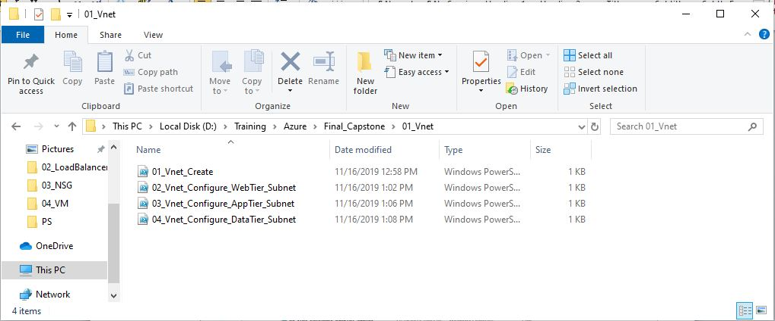

1. Execute **01_Vnet_Create.ps1** in Power Shell command line.

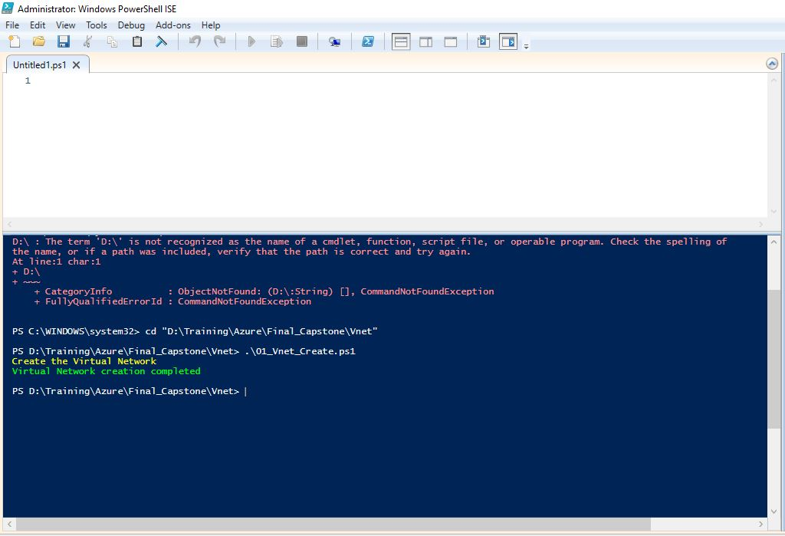

1. Verify the Virtual Network in in Azure portal

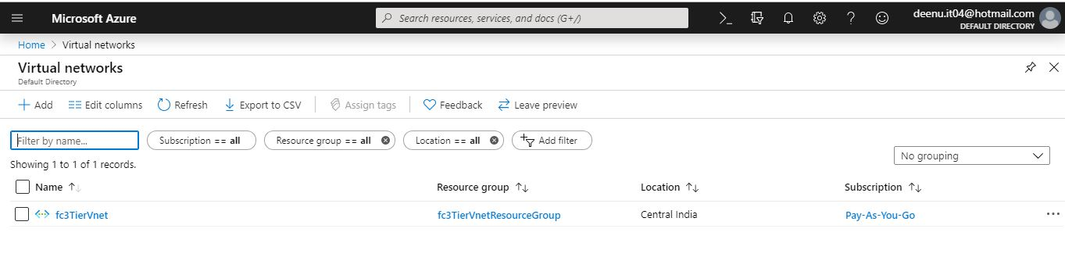

Step4: Create Subnet with name **WebTier** under **fc3TierVnet** and address space **192.168.1.0/24** in resource group **fc3TierVnetResourceGroup**.

1. Execute **02_Vnet_Configure_WebTier_Subnet.ps1** in Power Shell command line.

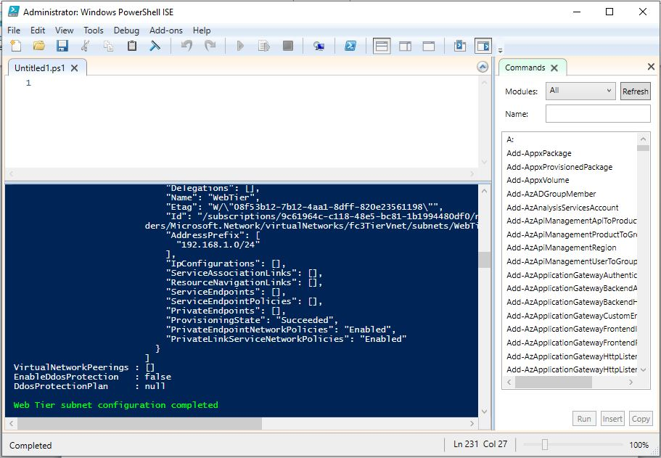

1. Verify the subnet in in Azure portal

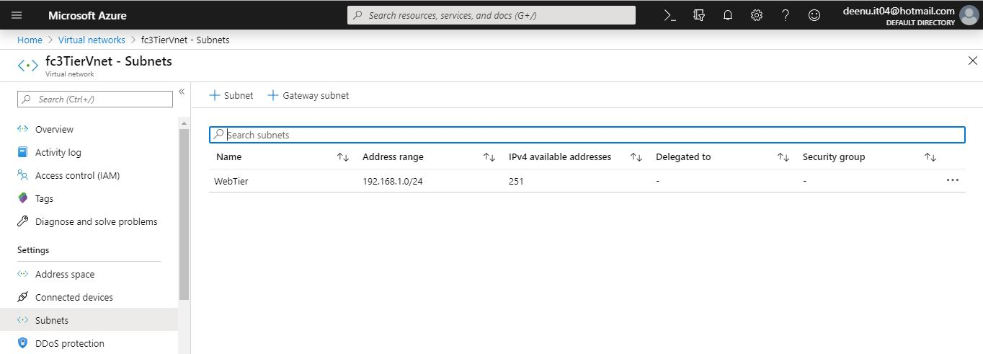

Step5: Create Subnet with name **AppTier** under **fc3TierVnet** and address space **192.168.2.0/24** in resource group **fc3TierVnetResourceGroup**.

1. Execute **03_Vnet_Configure_AppTier_Subnet.ps1** in Power Shell command line.

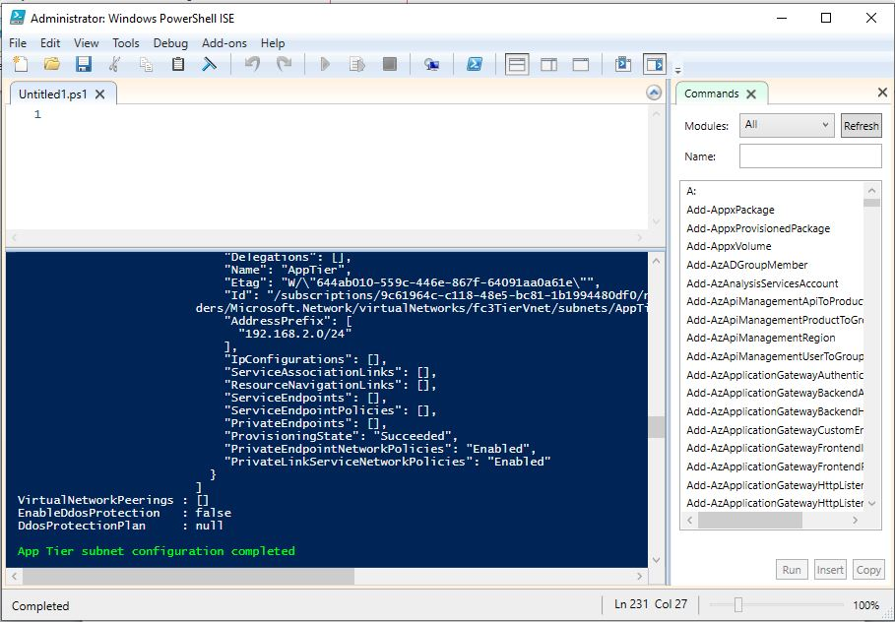

1. Verify the subnet in in Azure portal

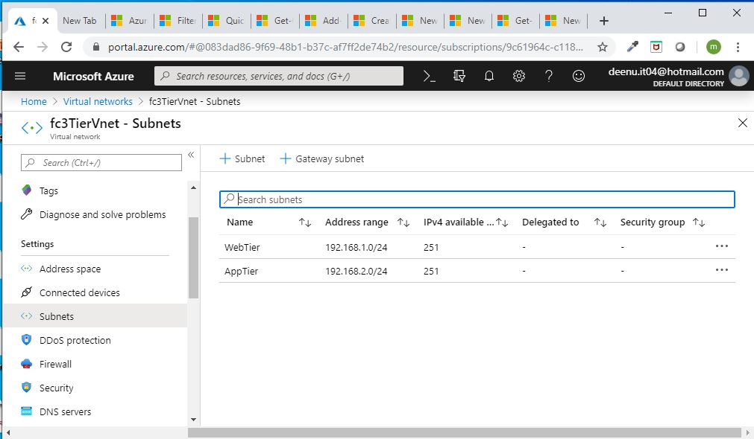

Step6: Create Subnet with name **DataTier** under **fc3TierVnet** and address space **192.168.3.0/24** in resource group **fc3TierVnetResourceGroup**.

1. Execute **04_Vnet_Configure_DataTier_Subnet.ps1** in Power Shell command line.

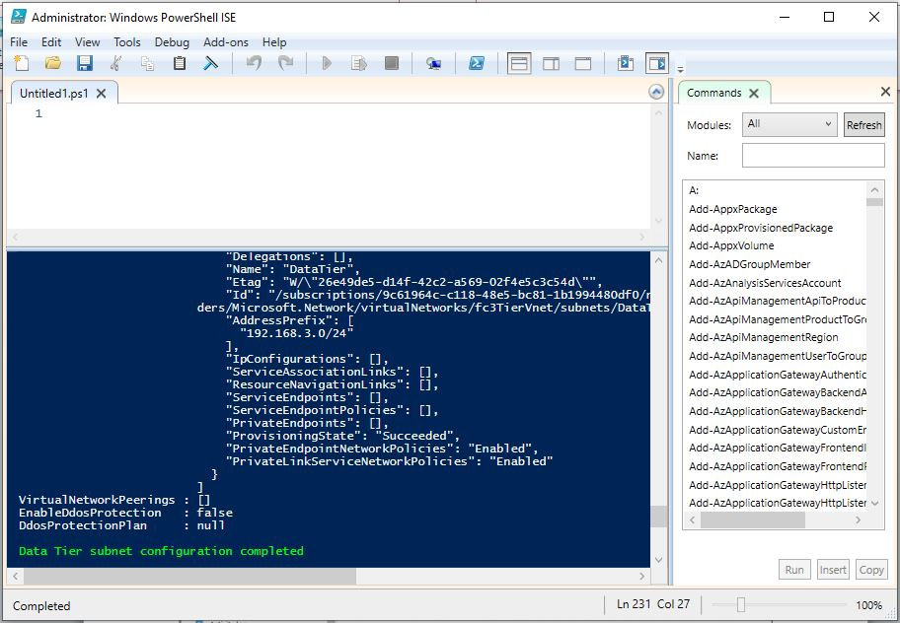

1. Verify the subnet in in Azure portal

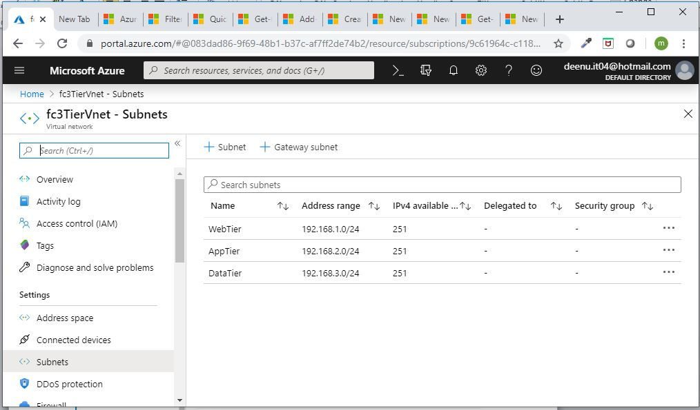

Step7: Create a public Load Balancer for web tier with name **fc3TierWebLoadBalancer** in resource group **fc3TierVnetResourceGroup**.

1. Go to folder **02_LoadBalancer**

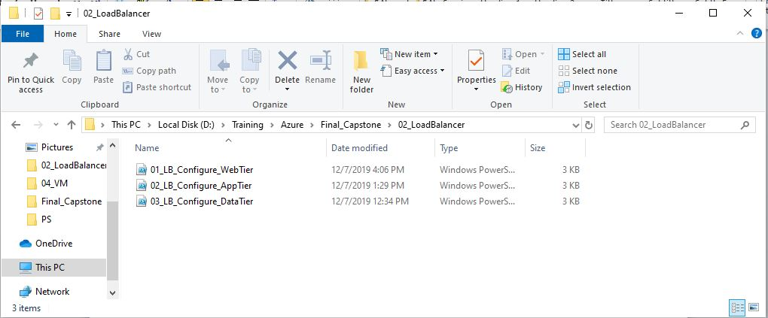

1. Execute **01_LB_Configure_WebTier.ps1** in Power Shell command line.

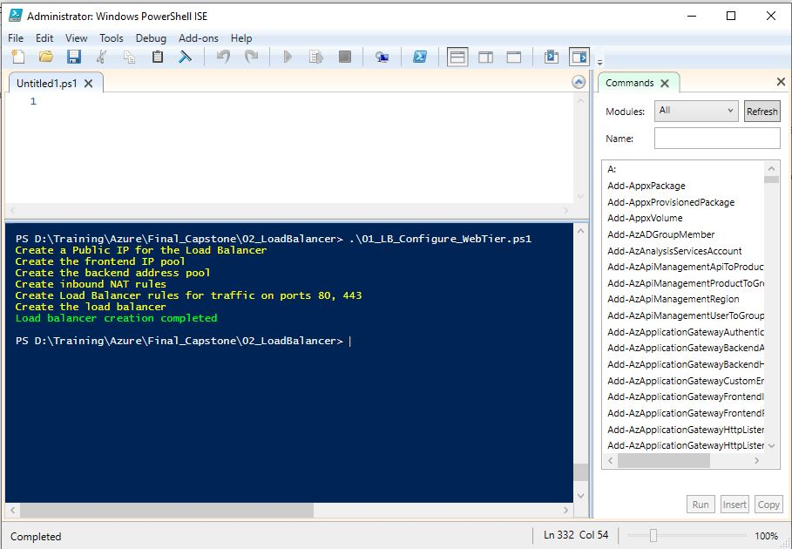

1. Verify the public IP and load balancer in Azure portal

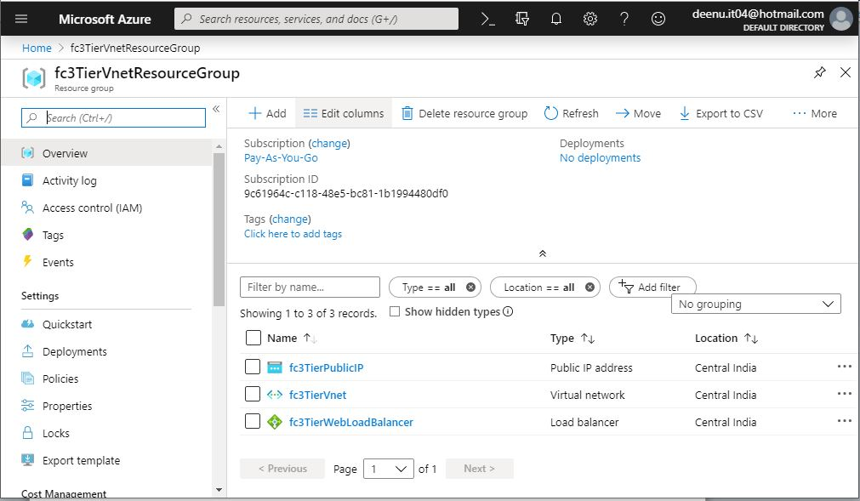

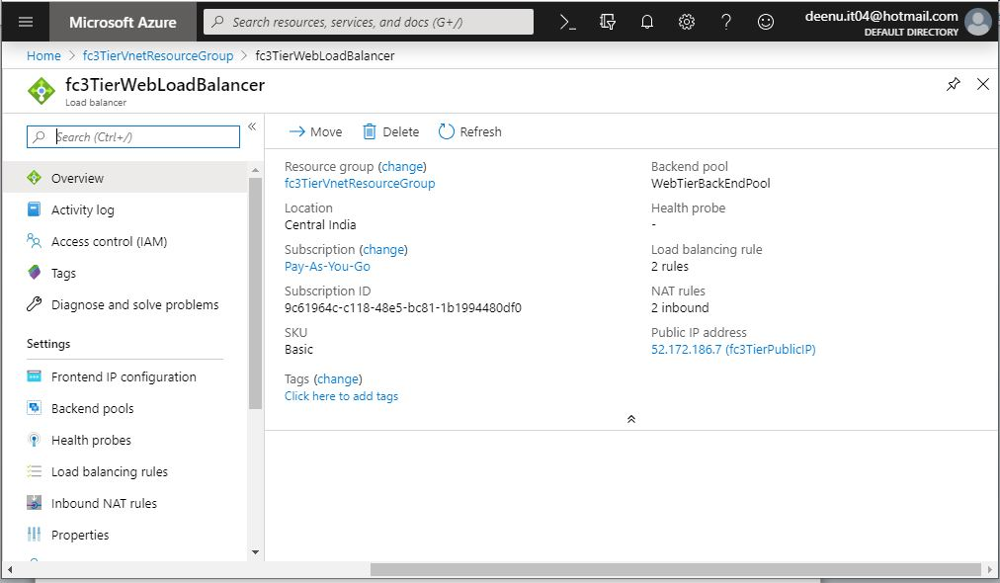

Step8: Create an internal Load Balancer for app tier with name **fc3TierAppLoadBalancer** in resource group **fc3TierVnetResourceGroup**.

1. Execute **02_LB_Configure_AppTier.ps1** in Power Shell command line.

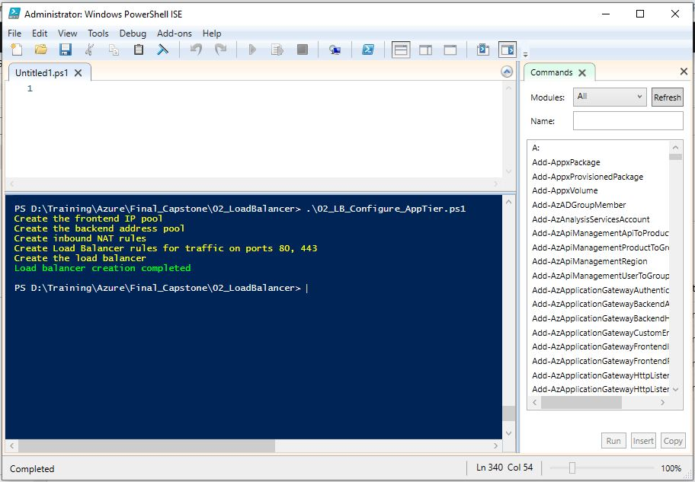

1. Verify the load balancer in Azure portal

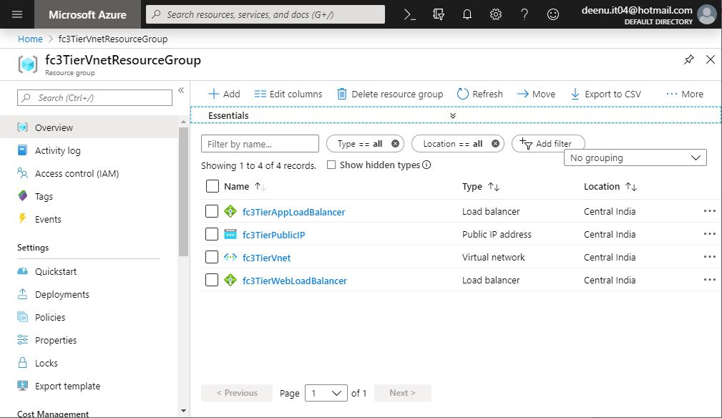

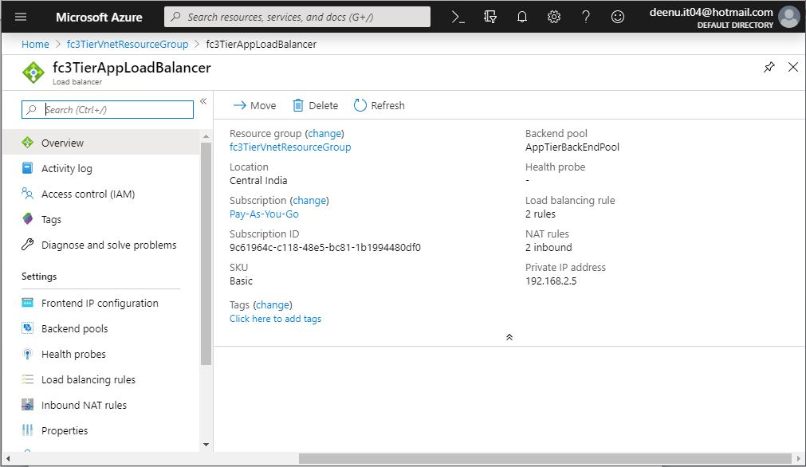

Step9: Create an internal Load Balancer for app tier with name **fc3TierDataLoadBalancer** in resource group **fc3TierVnetResourceGroup**.

1. Execute **03_LB_Configure_DataTier.ps1** in Power Shell command line.

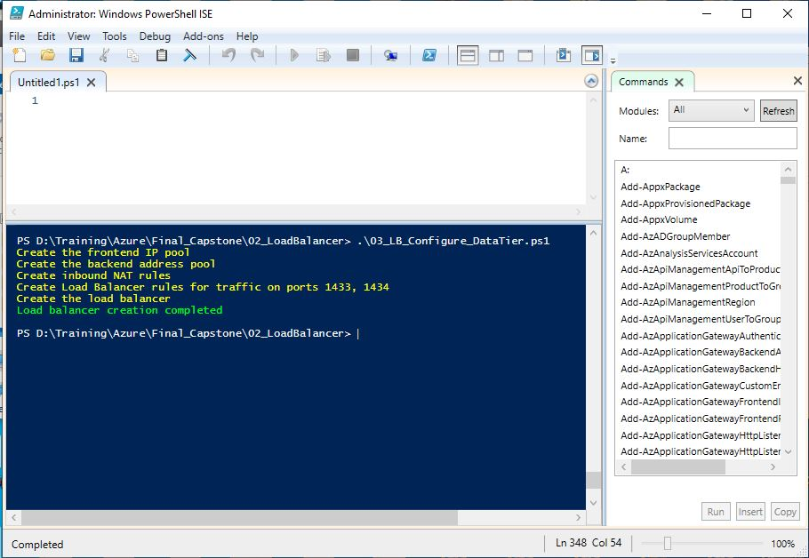

1. Verify the load balancer in Azure portal

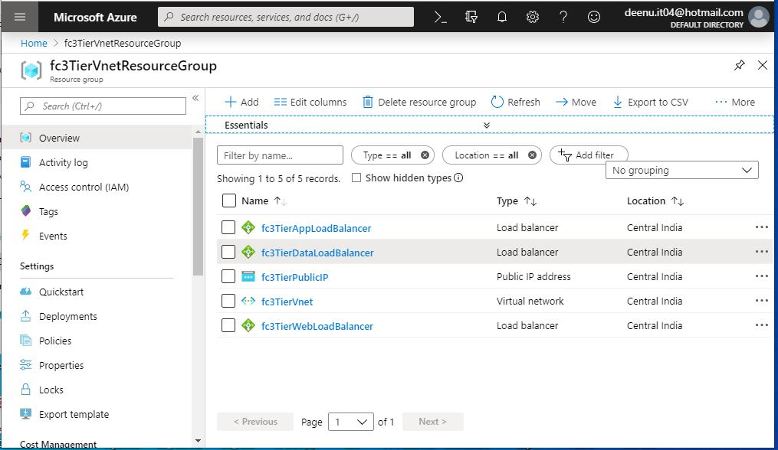

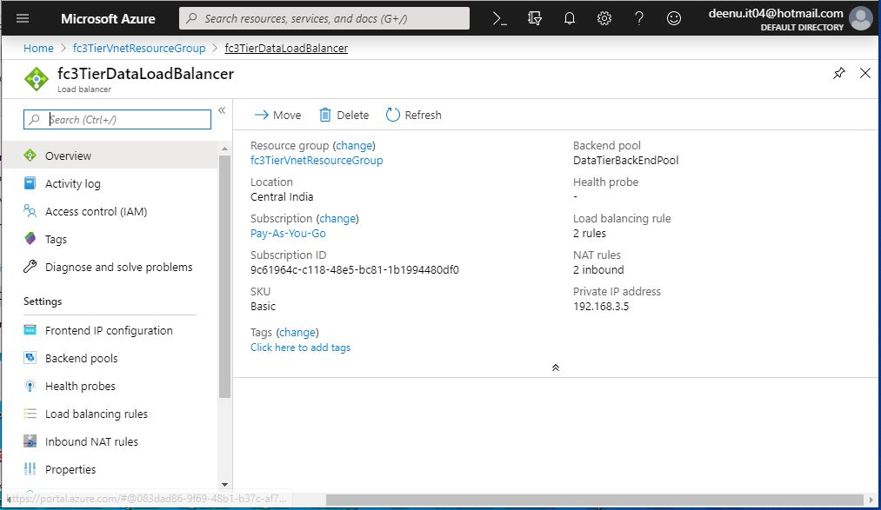

Step10: Create NSG for web tier with name **fcWebTierNsg** in resource group **fc3TierVnetResourceGroup**.

1. Go to folder **03_NSG**

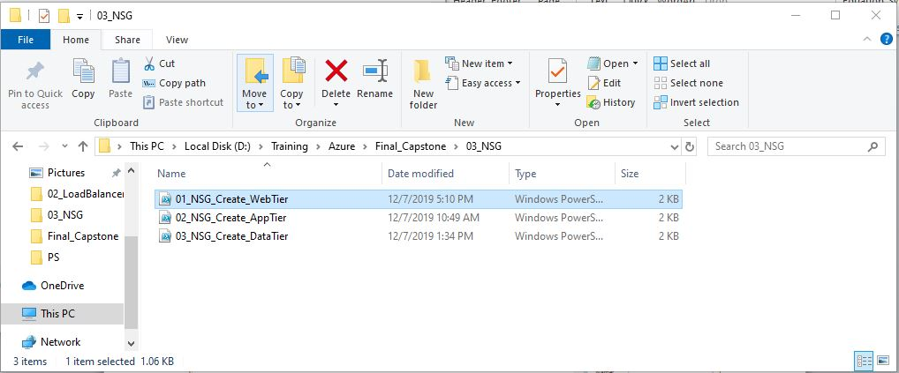

1. Execute **01_NSG_Create_WebTier.ps1** in Power Shell command line.

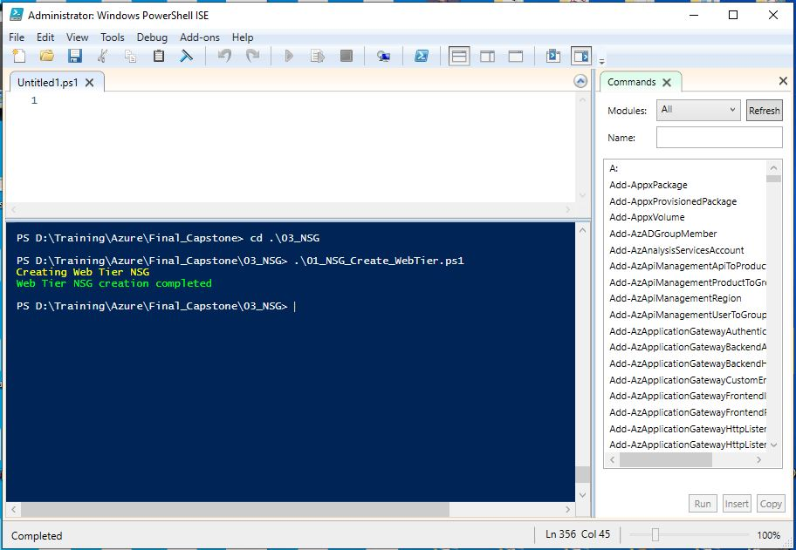

1. Verify NSG in Azure portal

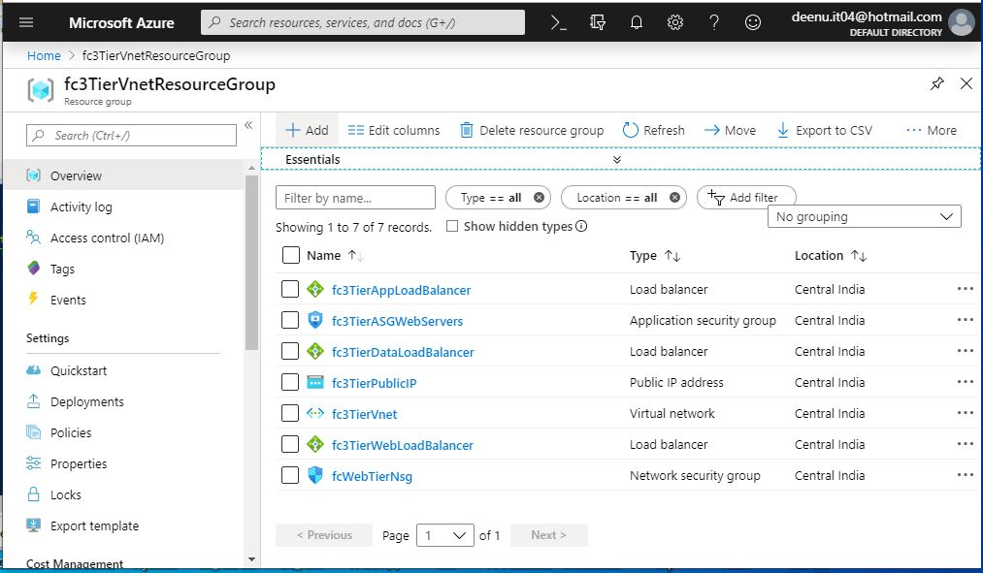

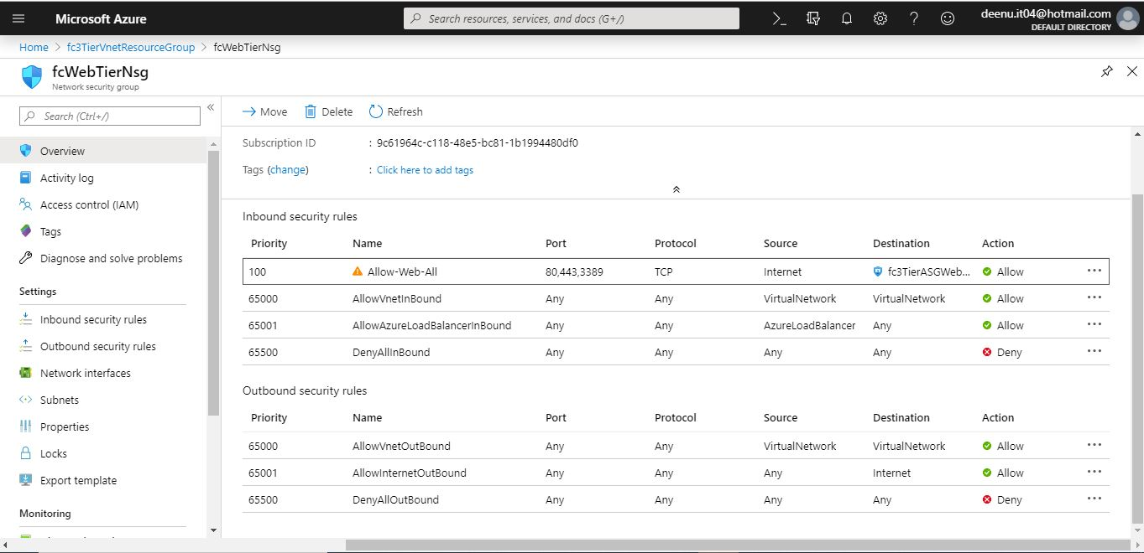

Step11: Create NSG for web tier with name **fcAppTierNsg** in resource group **fc3TierVnetResourceGroup**.

1. Execute **02_NSG_Create_AppTier.ps1** in Power Shell command line.

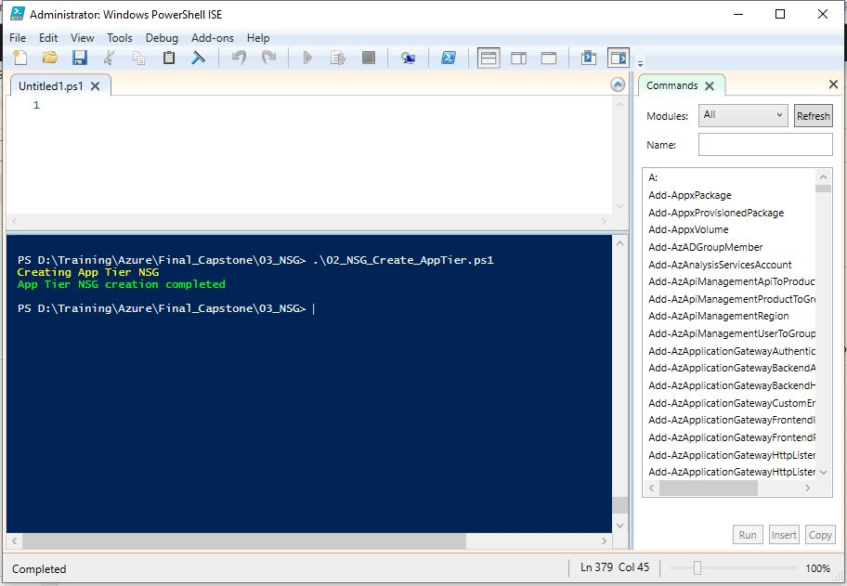

1. Verify NSG in Azure portal

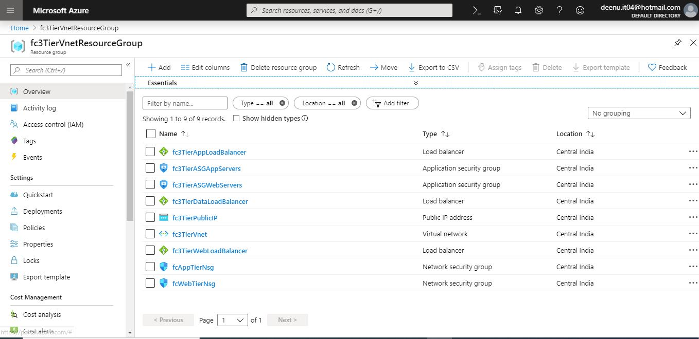

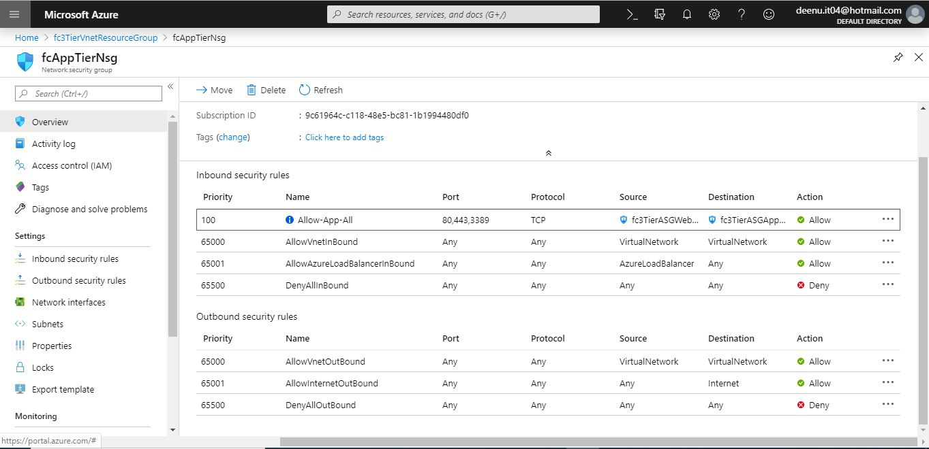

Step12: Create NSG for web tier with name **fcDataTierNsg** in resource group **fc3TierVnetResourceGroup**.

1. Execute **02_NSG_Create_DataTier.ps1** in Power Shell command line.

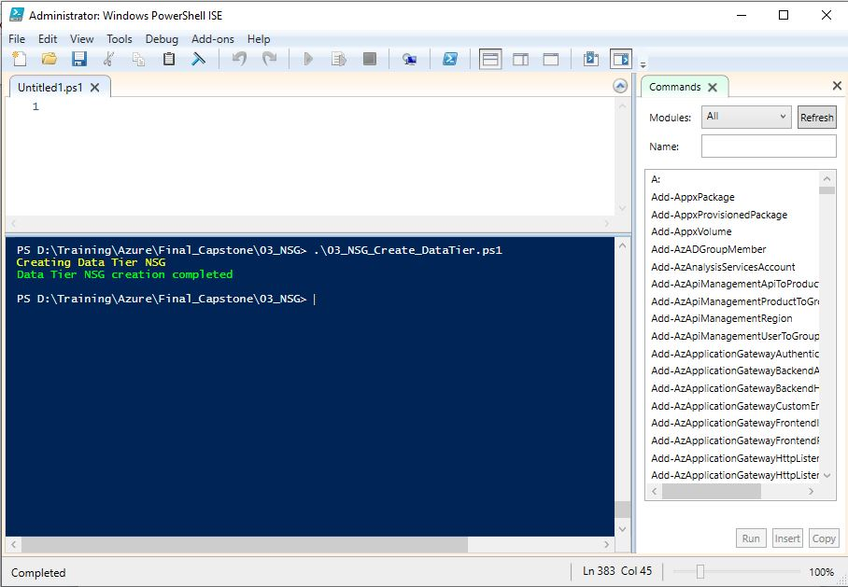

1. Verify NSG in Azure portal

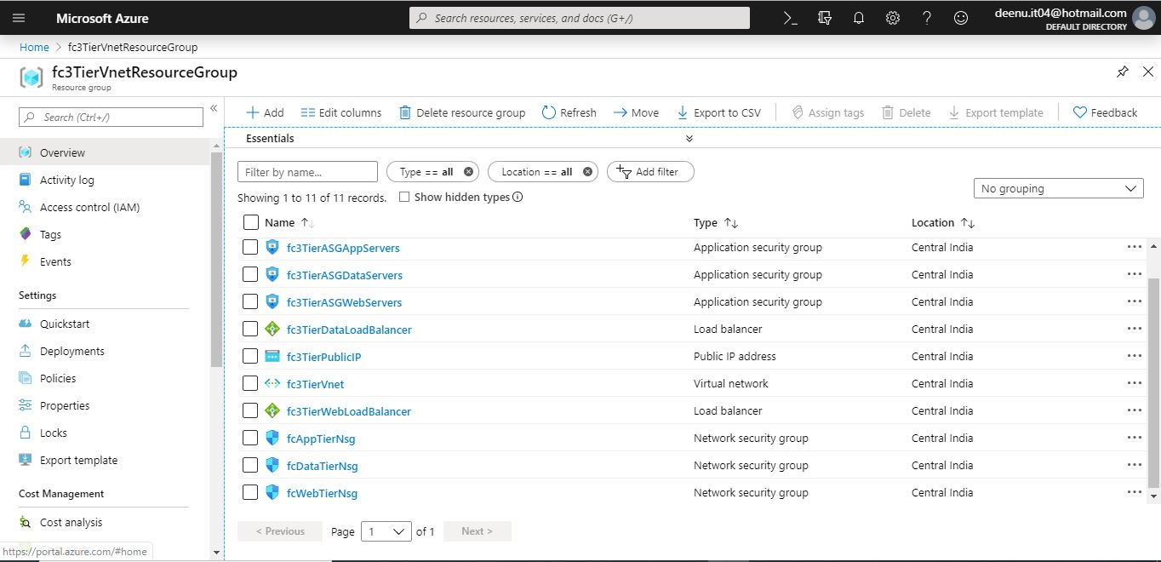

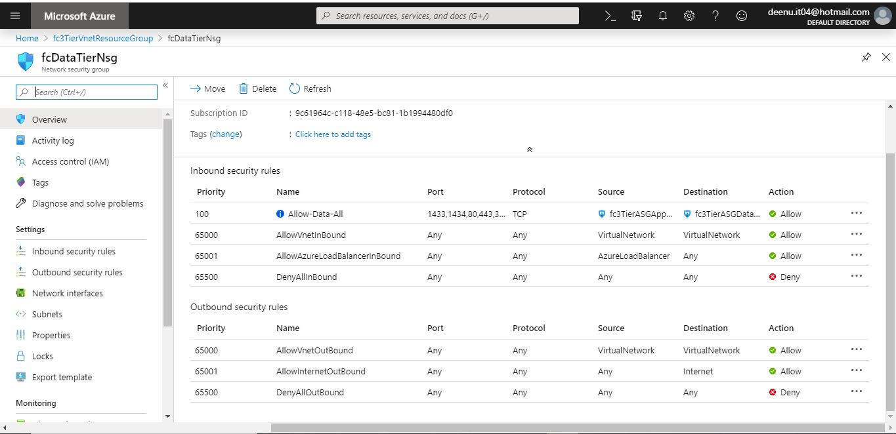

Step13: Create Availability Set for web tier with name **fcWebTierAvailabilitySet** , 2 Network interfaces with Network Security Group **fcWebTierNsg** and assigned to backend address pool of web tier load balancer **fc3TierWebLoadBalancer**  and 2 VMs in resource group **fc3TierVnetResourceGroup**.

1. Go to folder **04_VM**

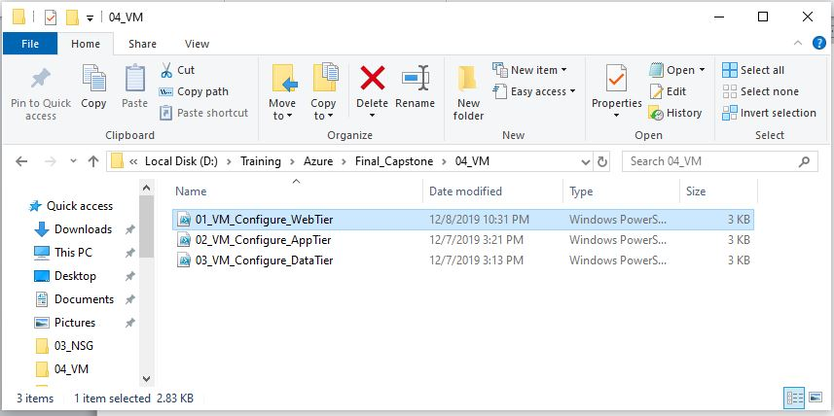

1. Execute **01_VM_Configure_WebTier.ps1** in Power Shell command line. Provide local admin user name and password for VMs when prompted.

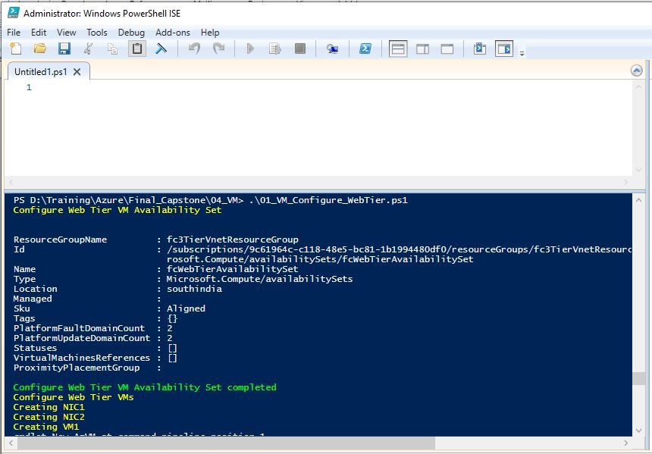

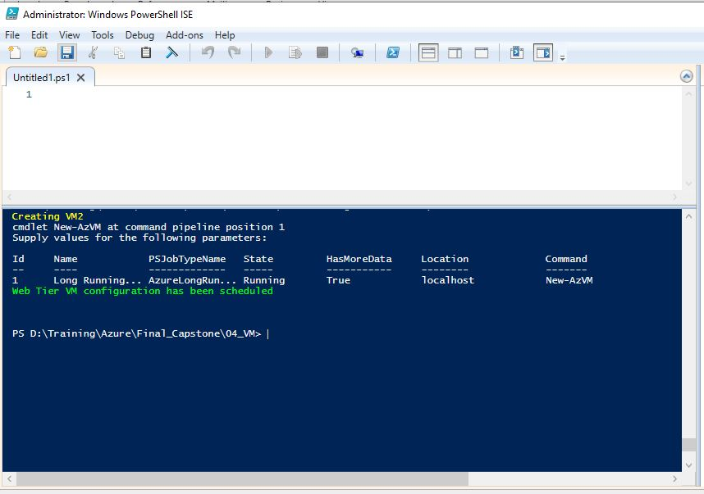

1. Verify Web Tier VMs in Azure portal. Please note both VMs have same Public IP (ie. Public IP of the Web tier load balancer) and different internal IPs.

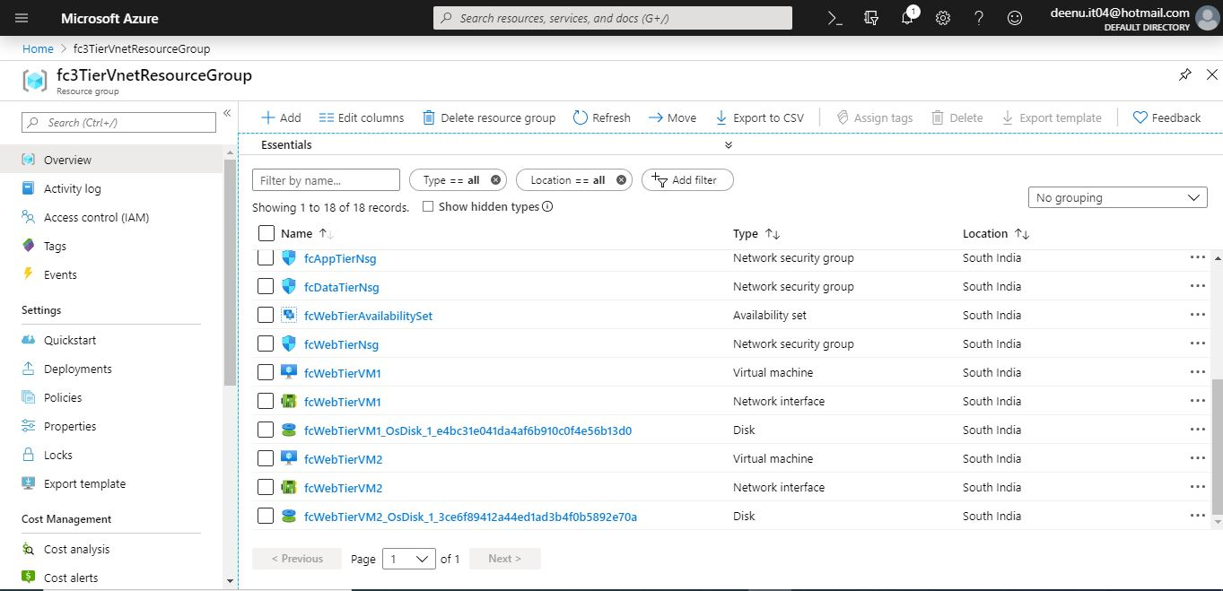

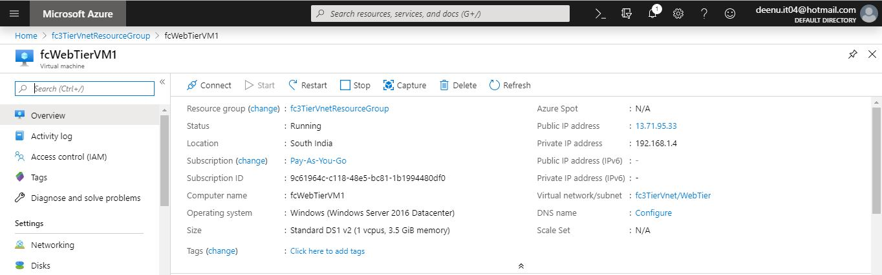

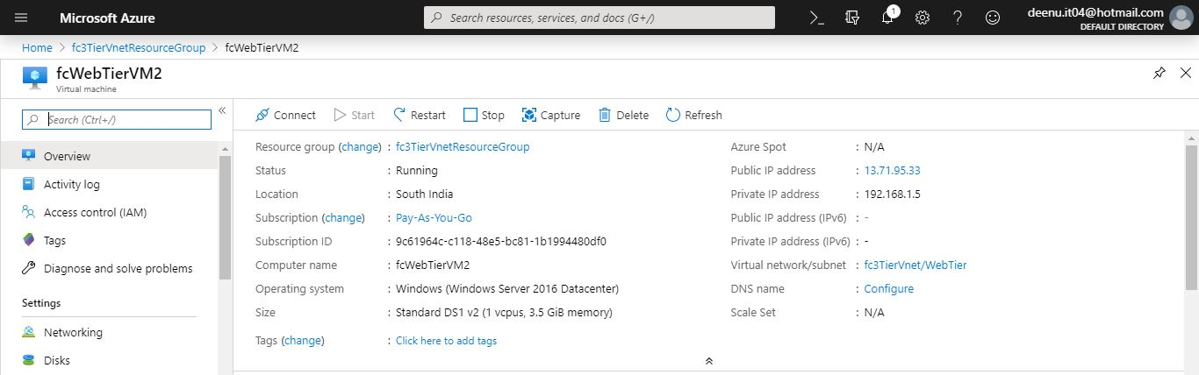

1. Test RDP connection to **fcWebTierVM1** using the following command. This ensures s the inbound NAT rules for RDP connection in the load balancer is working.

**mstsc /v:13.71.95.33:4221**

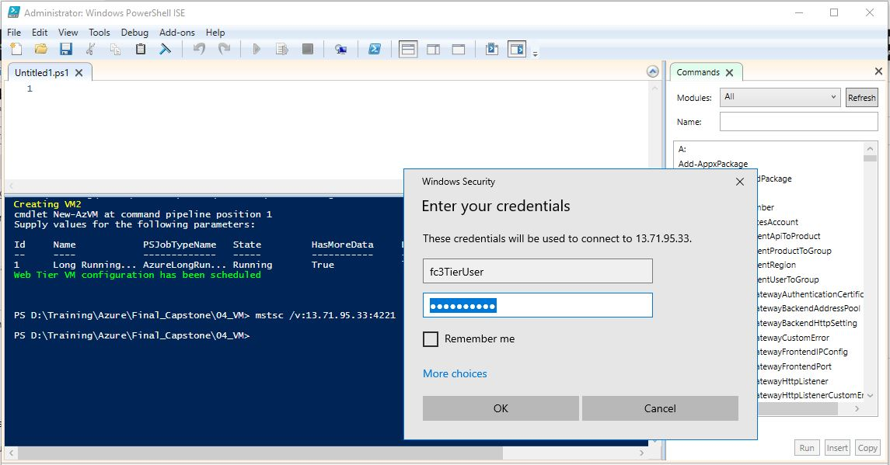

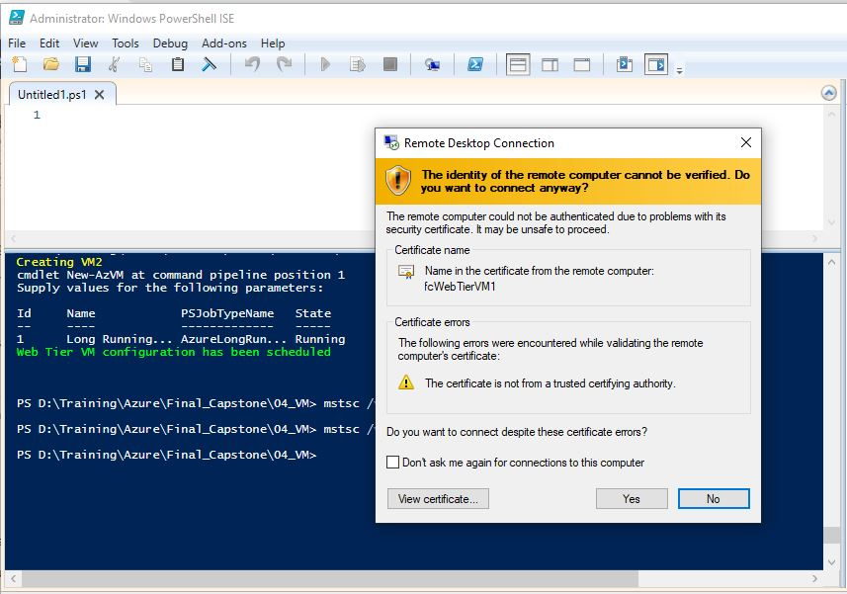

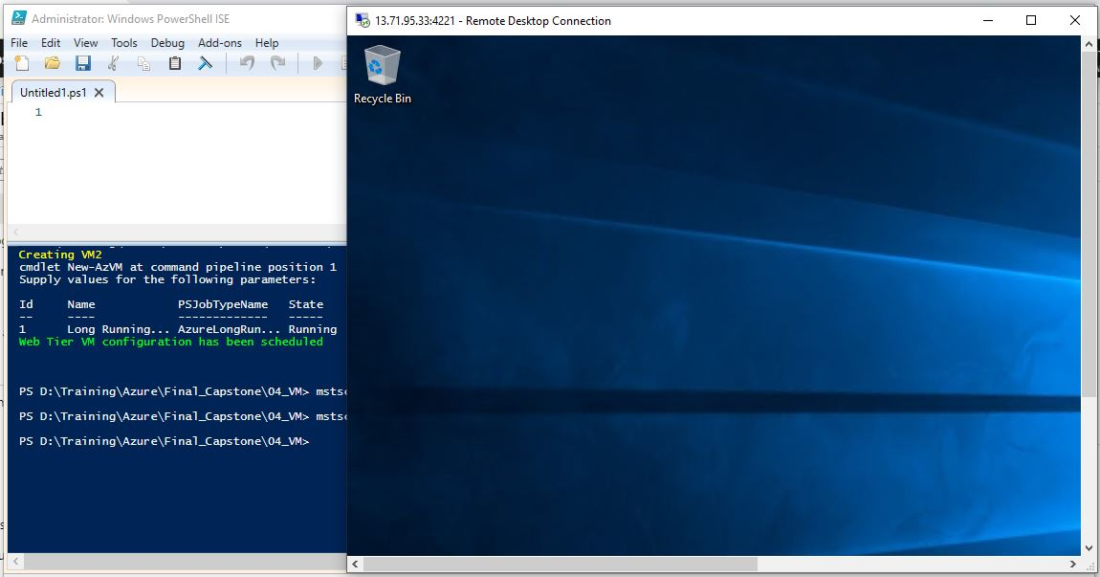

Step14: Create Availability Set for web tier with name **fcAppTierAvailabilitySet** , 2 Network interfaces with Network Security Group **fcAppTierNsg** and assigned to backend address pool of web tier load balancer **fc3TierAppLoadBalancer**  and 2 VMs in resource group **fc3TierVnetResourceGroup**.

1. Execute **02_VM_Configure_AppTier.ps1** in Power Shell command line.

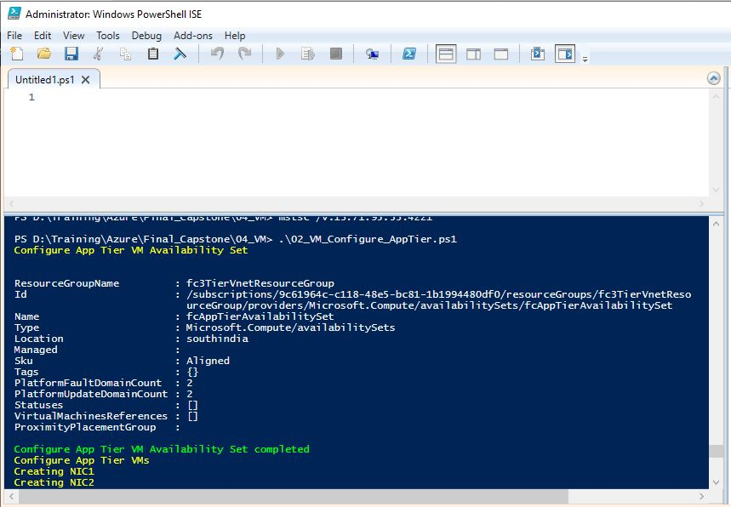

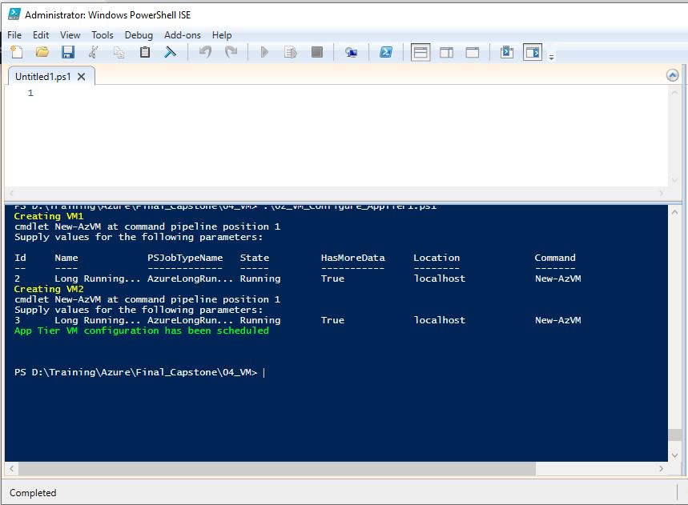

1. Verify App Tier VMs in Azure portal. Please note these VMs don’t have Public IPs. But RDP connection is allowed from Web Tier servers.

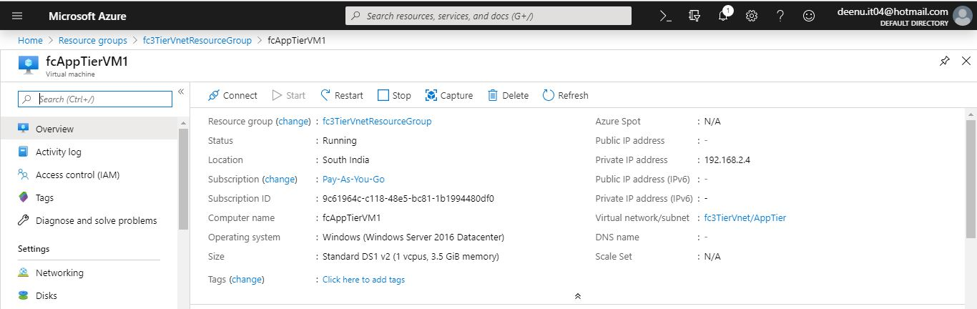

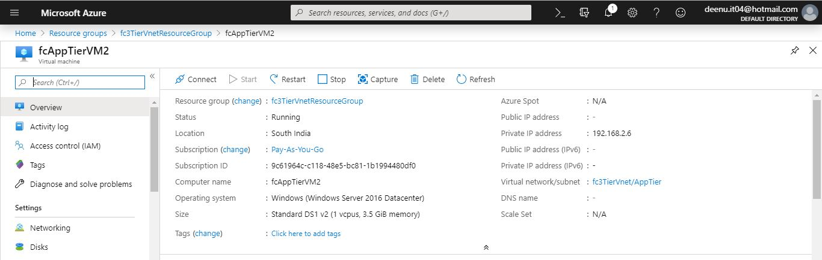

1. Test RDP connection to **fcAppTierVM1** using the following command from **fcWebTierVM1**. This ensures the inbound NAT rules for RDP connection in the load balancer is working.

**mstsc /v:192.168.2.5:3441**

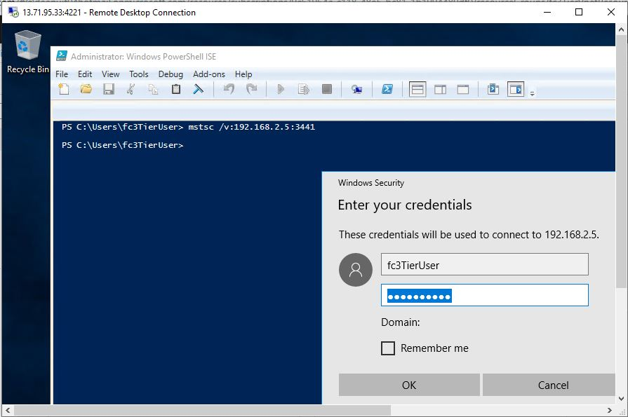

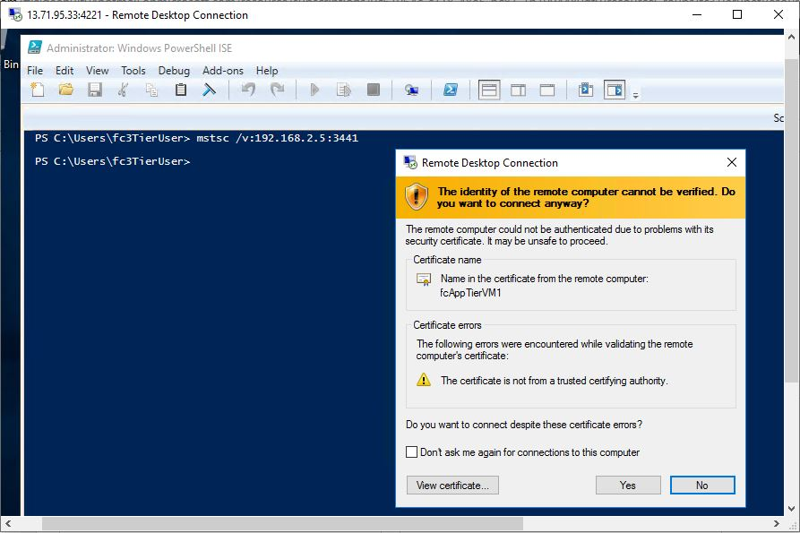

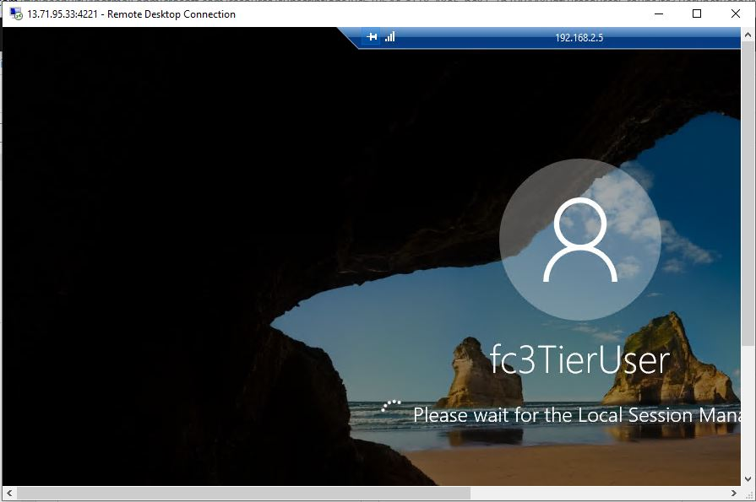

Step15: Create Availability Set for web tier with name **fcDataTierAvailabilitySet** , 2 Network interfaces with Network Security Group **fcDataTierNsg** and assigned to backend address pool of web tier load balancer **fc3TierDataLoadBalancer**  and 2 VMs in resource group **fc3TierVnetResourceGroup**.

1. Execute **03_VM_Configure_DataTier.ps1** in Power Shell command line.

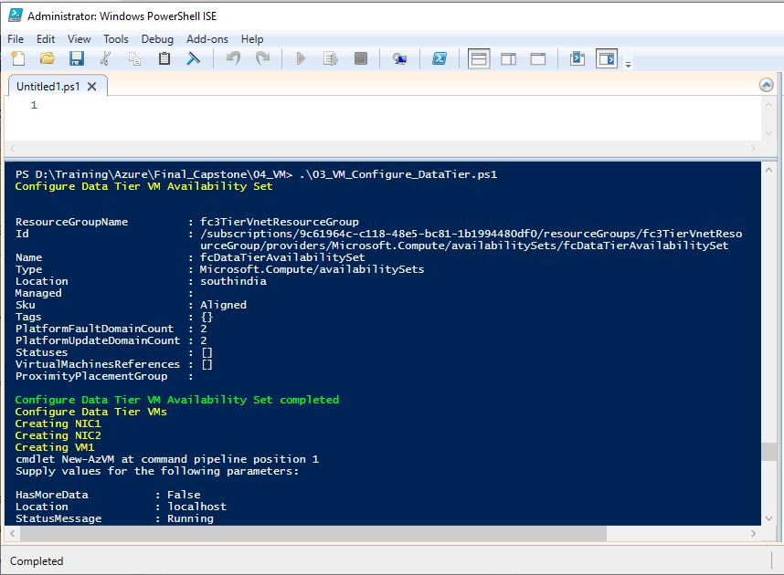

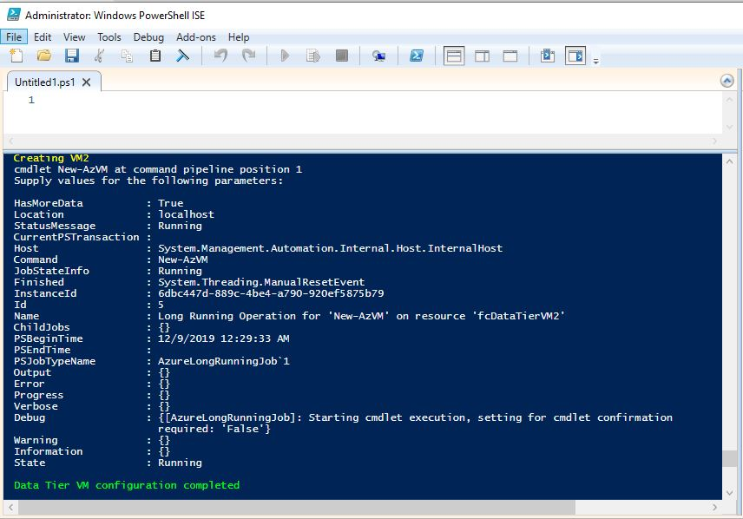

1. Verify Data Tier VMs in Azure portal. Please note these VMs don’t have Public IPs. But RDP connection is allowed from App Tier servers.

